Lab Report 3

**Name -** Pranesh Chowdhury

**ID -** 202003112

**1. Assembly language for dividing the value of a register by 4.**

**CODE:**

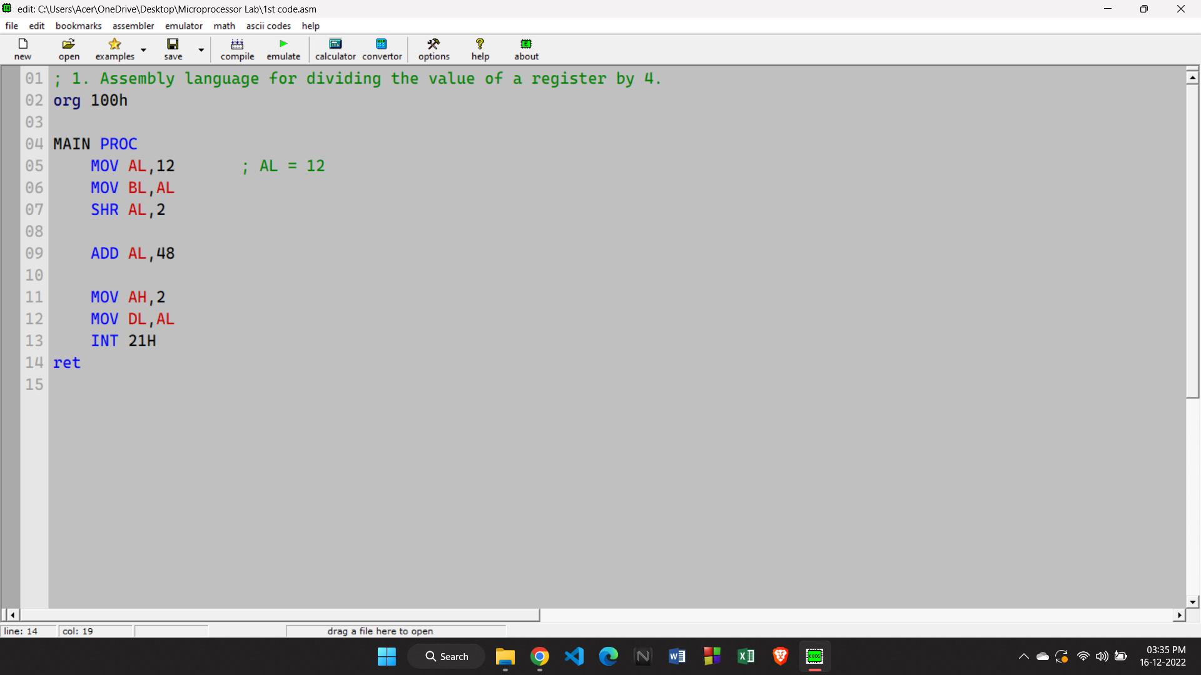

**OUTPUT:**

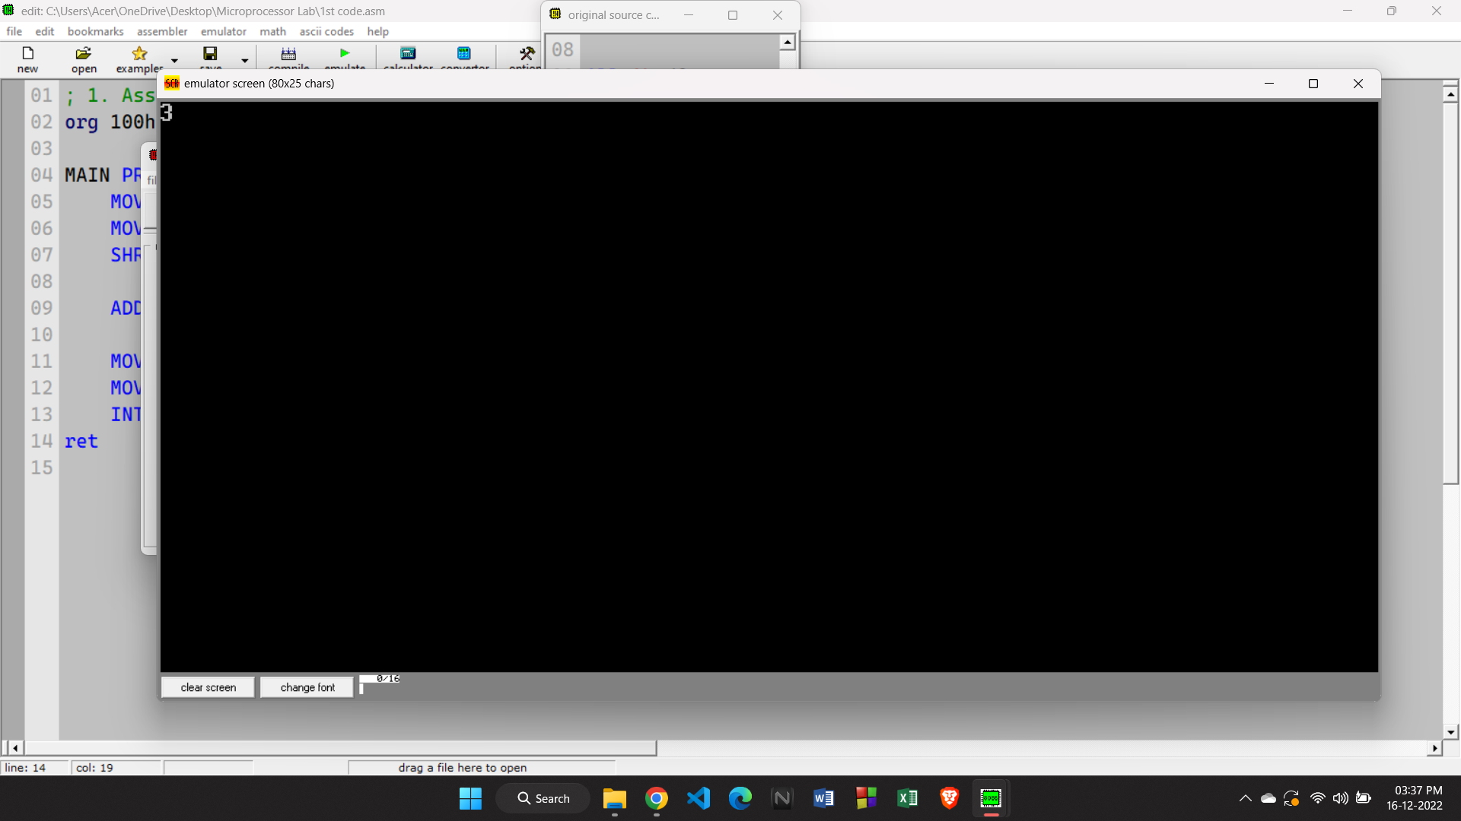

**2. Assembly language for converting an upper case letter into a lower case letter and vice versa.**

**CODE:**

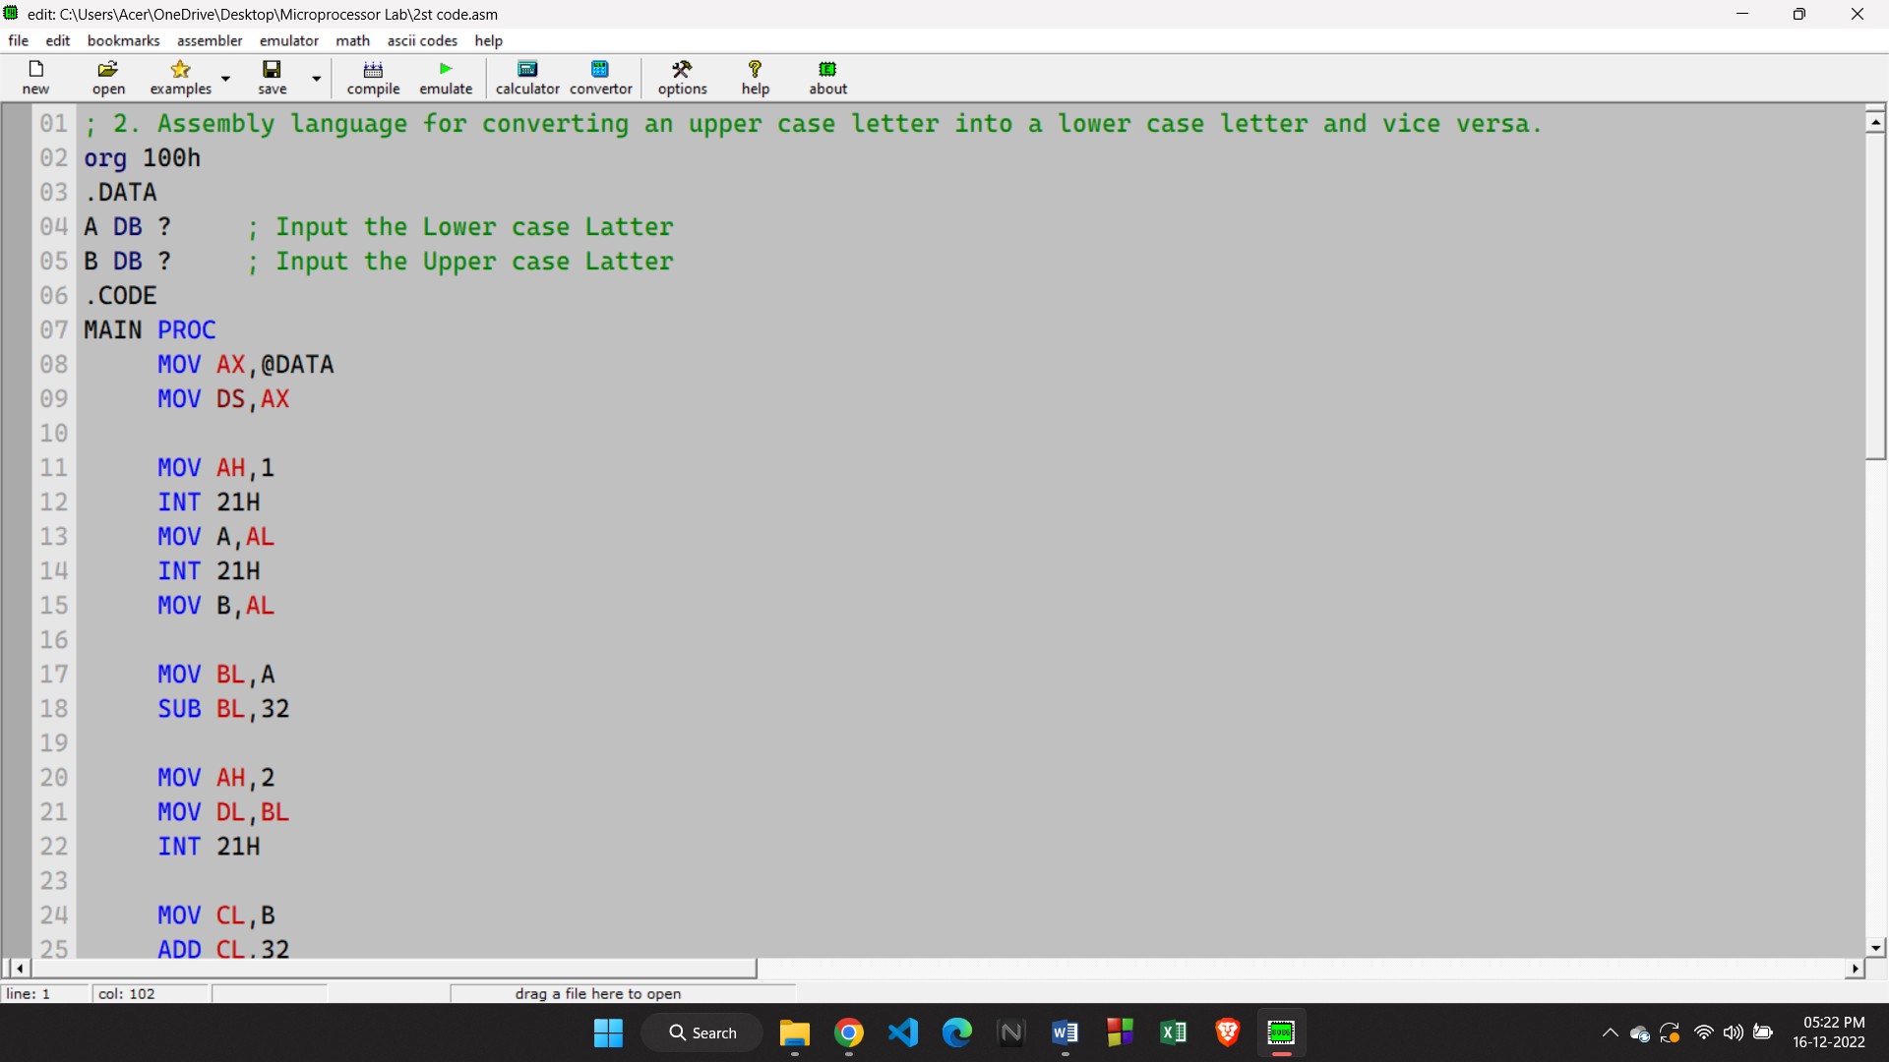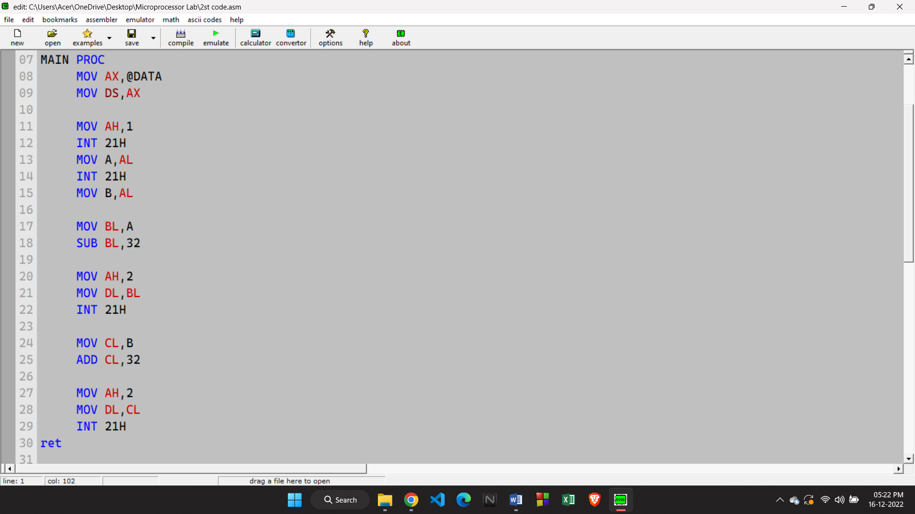

**OUTPUT:**

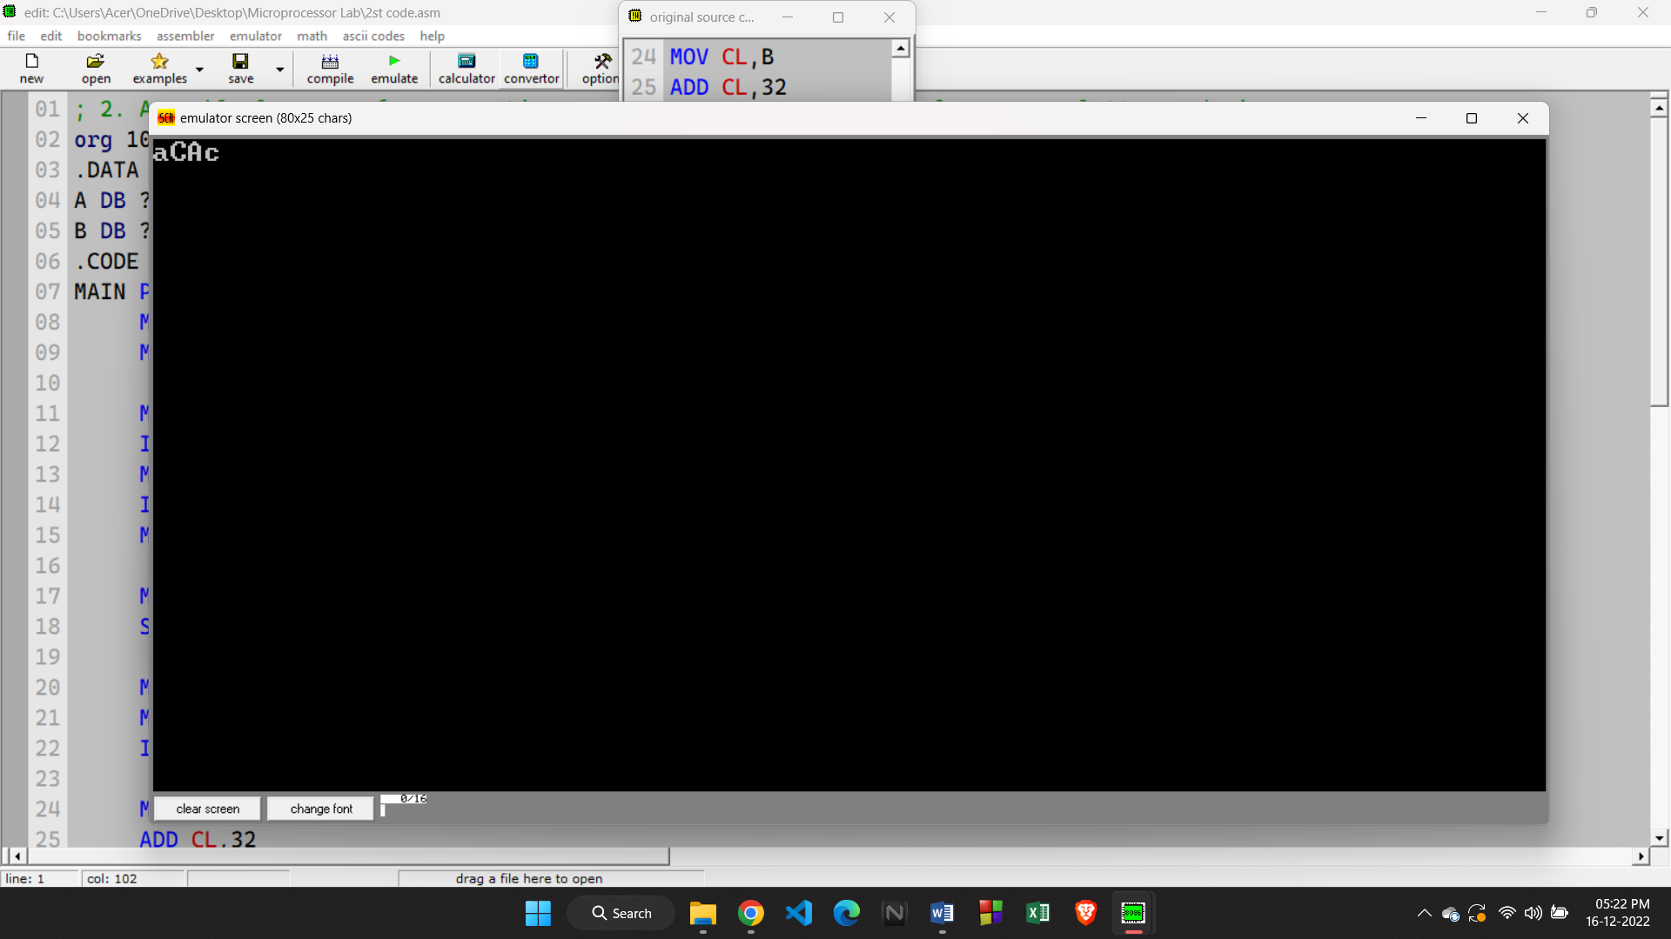

**3. Assembly language for checking if values of two registers are equal or not.**

**CODE:**

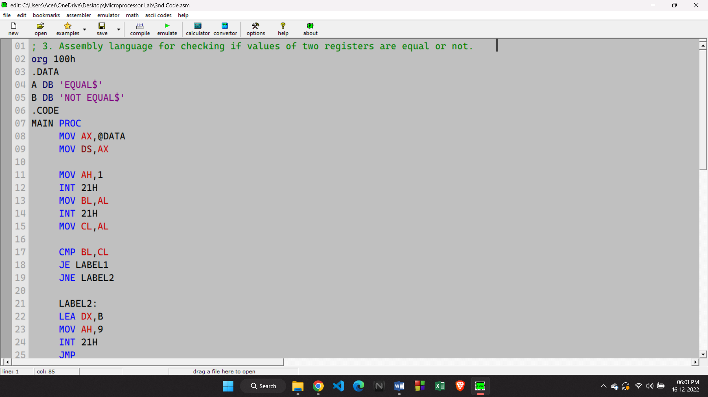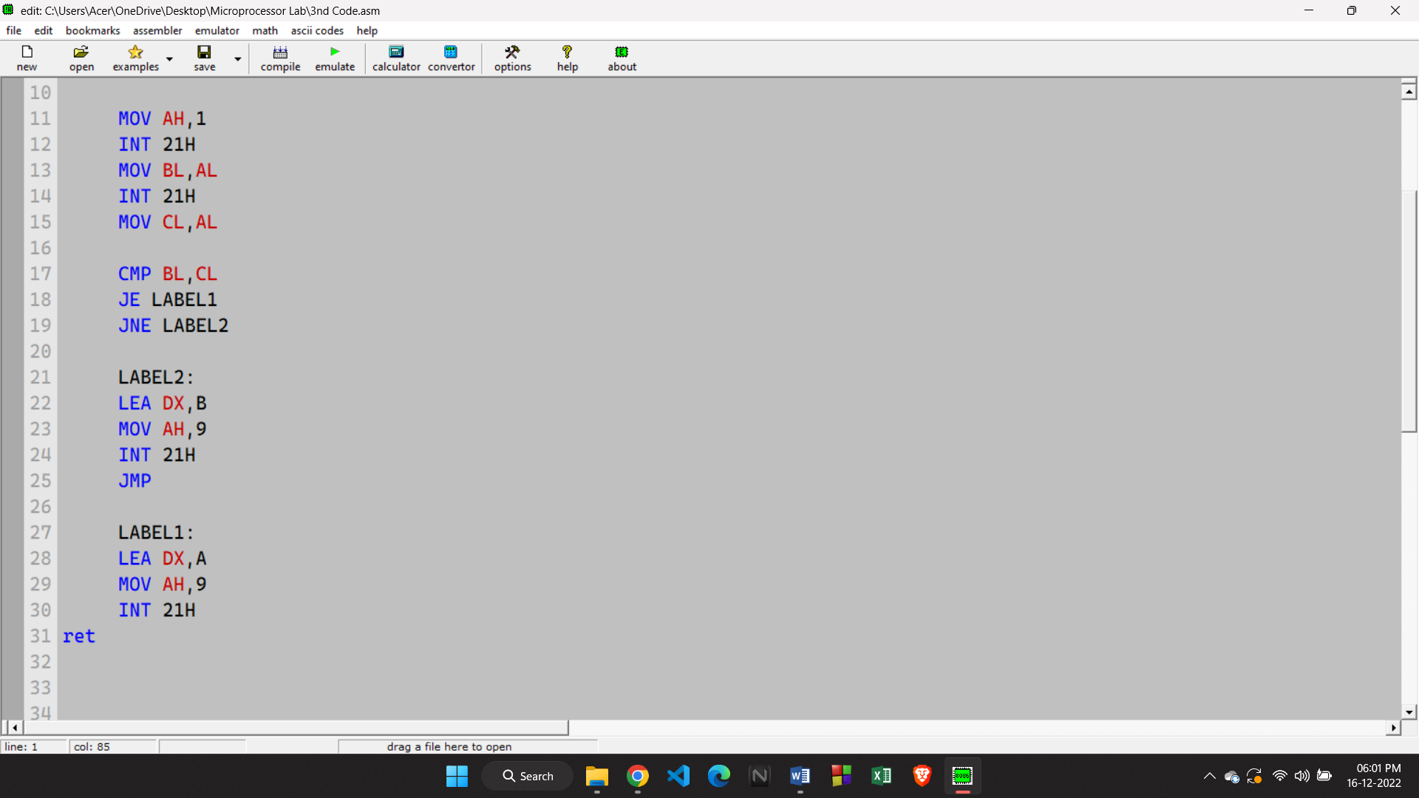

**OUTPUT:**

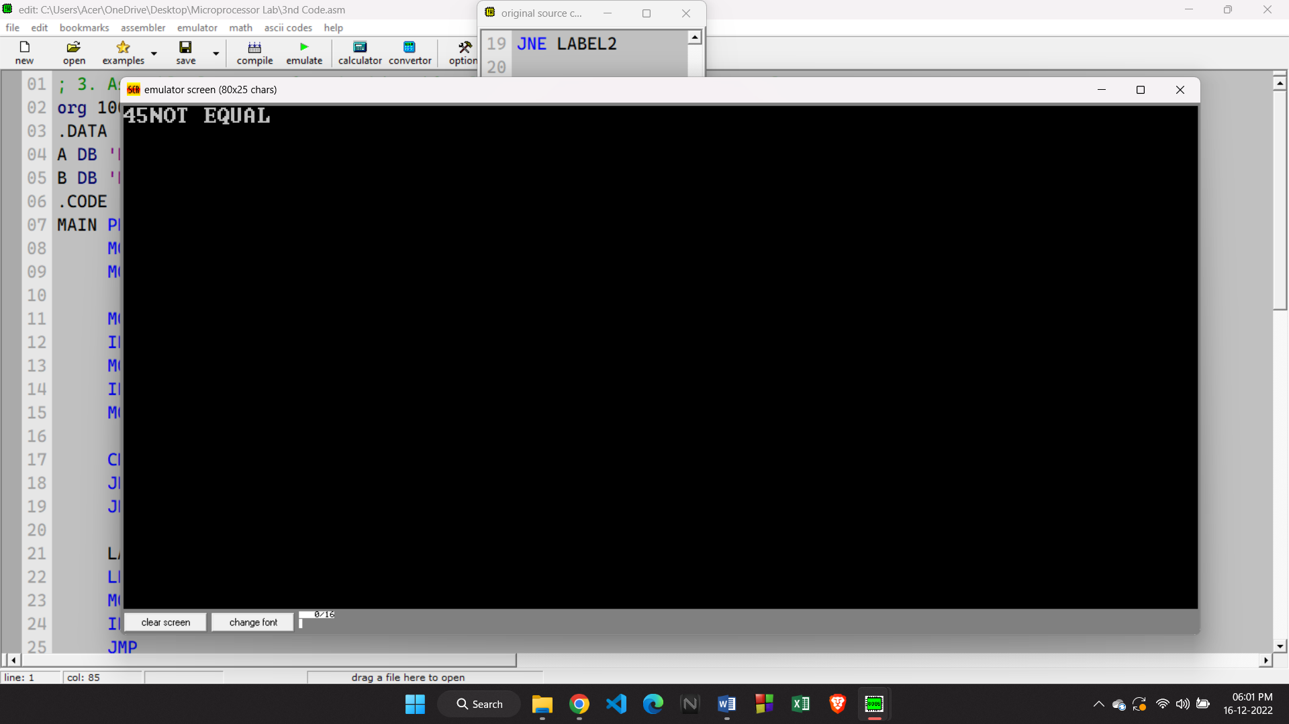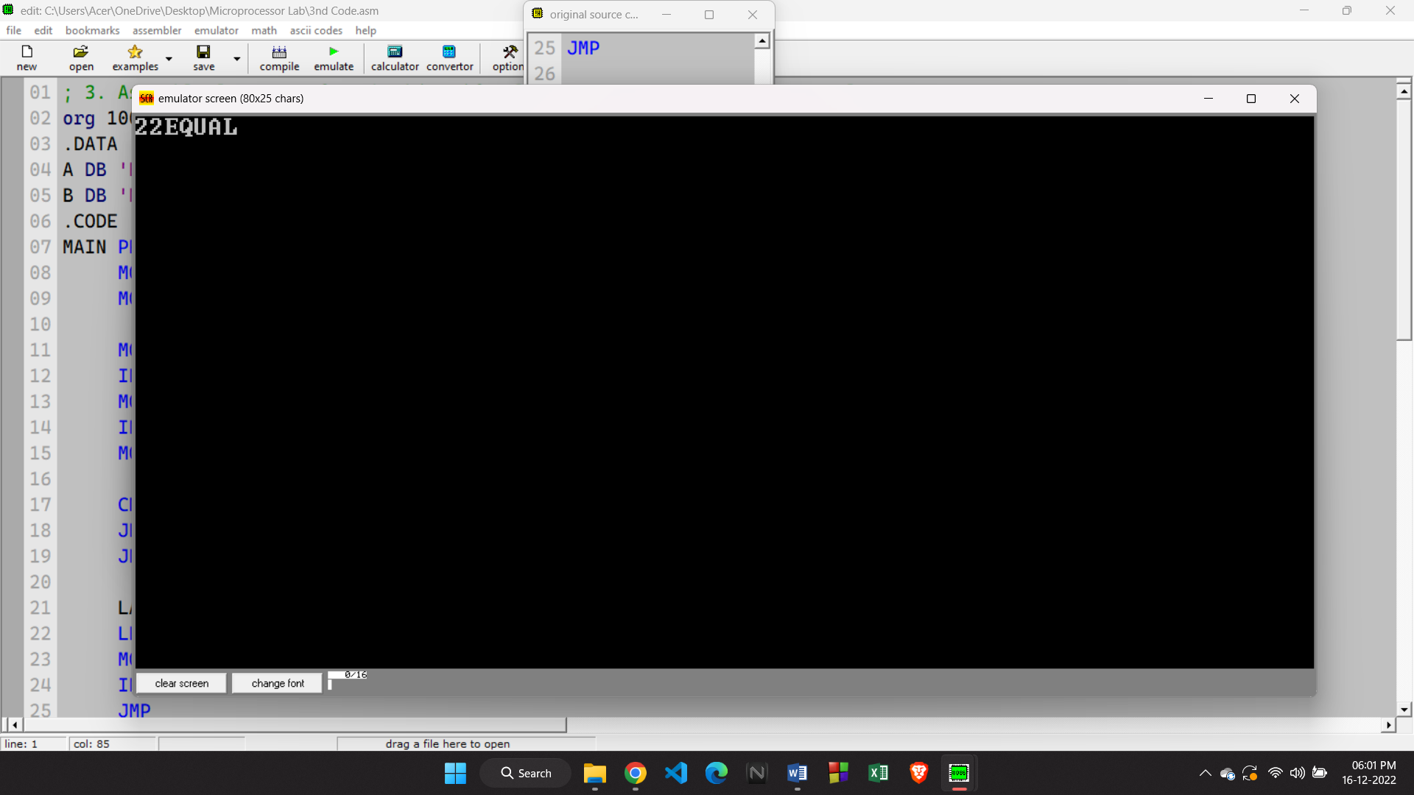

**4. Assembly language for multiplying the value of a register by 5.**

**CODE:**

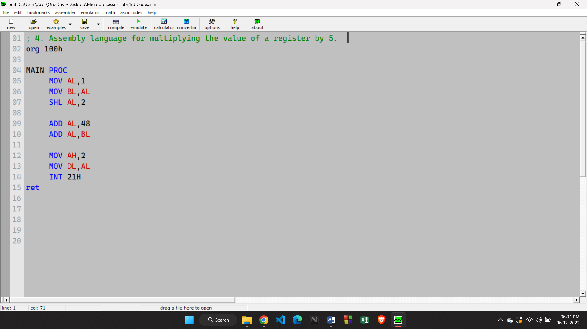

**OUTPUT:**

